**LESSON 4 PRACTICE ASSIGNMENT**

Using the concepts learnt in this lesson, recreate the custom VPC as show in the demonstration:

VPC Name: SIMPLILEARN_VPC  
CIDR: 10.0.0.0/16   
Subnets: 1 public (10.0.1.0) and 1 private (10.0.2.0) placed in separate availability zones  
Internet Gateway: 1  
NAT Gateway: 1  
Route Table: 1 (in the public subnet)  
Security Groups: SIMPLILEARN_WEBSERVER_SG and SIMPLILEARN_DBSERVER_SG

1. Login to AWS and open up VPC
2. Click on “Your VPCs” and then click on “Create VPC”
3. Enter the details as follows (you can change the name tags appropriately):

Name Tag: SIMPLILEARN_VPC

CIDR block: 10.0.0.0/16

Tenancy: Default

1. Click on “Yes, Create”
2. Click on “Subnets” and then “Create Subnet”
3. Configure the public and private subnets as follows, ensuring that you select the correct VPC and different availability zones. Click on “Create Subnet”
4. Name the public subnet as SIMPLILEARN_WEBSERVER and private subnet as SIMPLILEARN_DBSERVER

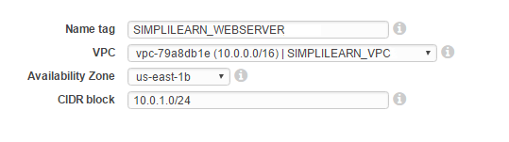

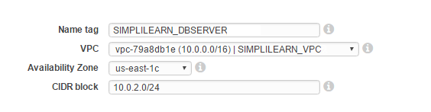

1. Click on “Internet Gateways” and select “Create Internet Gateway”
2. Enter the name tag for the “Internet Gateway” and click “Yes, Create”
3. Highlight the new Internet gateway in the list and click on “Attach to VPC”
4. Select your VPC from the dropdown box and click “Yes, Attach”
5. Click on “NAT Gateways” and click “Create a NAT Gateway”
6. In the Subnet box, select the SIMPLILEARN_DBSERVER from the drop-down list to attach NAT gateway to the private subnet
7. Click “Create New EIP” and then click “Create a NAT Gateway”
8. In the window that opens up, click on “Edit Route Tables”
9. Click “Create Route Table” and give the new route table a name, for example SIMPLILEARN_VPC_CUSTOM_RTB. Ensure that the VPC selected is your new VPC. Click “Yes, Create”
10. Highlight the new route table in the list and click on the “Routes” tab
11. Click on “Add another route” and enter the following:

Destination: 0.0.0.0/0

Target: Select your Internet gateway from the drop-down list

1. Click “Save”
2. Click on the “Subnet Associations” tab and click “Edit” to attach the custom route table to the public subnet
3. Highlight the SIMPLILEARN_WEBSERVER subnet and click Save
4. Locate the main route table for your VPC (look in the main column for the route table that has Yes next to it). Give this main route table a name, for example SIMPLILEARN_RTB_MAIN, so you can easily identify it
5. Highlight the main route table and click on “Routes”
6. Click “Edit” and then “Add another route” and enter the following:

Destination: 0.0.0.0/0

Target: Select your NAT Gateway from the drop down list

1. Click “Save”
2. Navigate to the AWS VPC console
3. In the navigation pane, choose “Security Groups”
4. Click on “Create Security Group”
5. Enter the name of the security group as SIMPLILEARN_WEBSERVER_SG
6. In VPC menu, select the ID of the custom VPC created in the previous steps
7. Click on “Yes, Create”
8. Go back to the VPC console, choose “Security Groups” in the navigation pane
9. Select the SIMPLILEARN_WEBSERVER_SG security group
10. Choose “Actions” and click on “Edit Inbound Rules”
11. From the type drop-down menu, choose HTTP rule
12. Select anywhere in the source drop-down menu
13. Add description(optional)
14. Click on “Add Rule” and choose HTTPS from the type drop-down menu
15. Select anywhere in the source drop-down menu
16. Add description (optional)
17. Click on “Add Rule” and choose SSH from the type drop-down menu
18. Choose “Save Rules”
19. Navigate to the AWS VPC console
20. In the navigation pane, choose “Security Groups”
21. Click on “Create Security Group”
22. Enter the name of the security group as SIMPLILEARN_DBSERVER_SG
23. In the VPC menu, select the ID of the custom VPC created in the previous steps
24. Click on “Yes, Create”
25. Go back to the VPC console and choose “Security Groups” in the navigation pane
26. Select the SIMPLILEARN_DBSERVER_SG security group
27. Choose “Actions” and click on “Edit Inbound Rules”
28. From the type drop-down menu, choose the MYSQL/Aurora rule
29. Enter SIMPLILEARN_WEBSERVER_SG in the source field and select it from the suggestions
30. Choose “Save Rules”